# CHAPTER 1 INTRODUCTION

**Chapter - 1**

**INTRODUCTION**

## Overview

“REACH” revolves around the development of a user-centric Android application tailored to address the multifaceted challenges associated with ensuring the wellbeing of the elderly. The application is designed to seamlessly integrate real-time health tracking, secure communication features, and emergency notifications. At its core, the primary objective is to empower both the elderly individuals and their caregivers with a comprehensive tool that enhances health monitoring, fosters secure communication, and expedites emergency response. In terms of health tracking, the application will leverage real-time data collection mechanisms to monitor vital health metrics such as heart rate, blood pressure, and physical activity. This information will be presented in an accessible and user-friendly interface, allowing both seniors and their caregivers to track health trends over time.

The goal is to provide actionable insights that facilitate proactive health management. The secure communication aspect of the application aims to bridge the gap between elderly individuals and their support networks. Features like video calls, messaging, and voice communication will be incorporated, prioritizing user-friendly interfaces for seniors. Privacy and security will be paramount, ensuring that sensitive health information and personal communication remain protected. In emergency situations, the application will employ a robust notification system to alert designated contacts or emergency services promptly. This feature can be triggered by predefined health thresholds or manually activated by the user. The goal is to expedite response times during critical moments, providing a safety net for elderly individuals living independently.

The "REACH" application's comprehensive approach extends beyond the core features of health tracking, secure communication, and emergency notifications. Recognizing the diverse needs of the elderly population, the application also incorporates personalized reminders and scheduling functionalities. Users will be able to set customizable alerts for medication intake, appointment reminders, and daily routines, ensuring that seniors can maintain their independence while receiving the necessary support. Additionally, the

application will feature a robust social integration component, enabling elderlyindividuals to connect with their loved ones and participate in virtual community activities. This can include features like shared calendars, group messaging, and even virtual social events, fostering a sense of belonging and reducing the risk of social isolation.

## Objectives

1. **Fraudulent Activities and Network Security:** Implementing measures to detect and prevent fraudulent activities while ensuring the security of sensitive data in an elderly care system involves implementing robust data encryption techniques, strict access control measures, advanced fraud detection algorithms utilizing machine learning, comprehensive auditing and monitoring mechanisms, and regular security audits and vulnerability assessments.
2. **Booking Appointments:** Developing a user-friendly online appointment booking system involves creating an intuitive interface for caregivers and elderly individuals to schedule and manage appointments efficiently. The system should include features such as a clear and easy-to-navigate booking platform with calendar views, appointment reminders via email or SMS, options for rescheduling or canceling appointments,
3. **Keeping Track of Psychological Behavior:** Developing tools to monitor and analyze the psychological well-being of the elderly involves creating user-friendly interfaces for data collection and analysis. These tools will include features such as mood tracking, activity logs, and communication channels for caregivers and mental health professionals.
4. **Constant Updates to Family**: Developing an AI-based alert system for the elderly involves integrating sensors and smart devices to detect unusual activities or emergencies such as falls, changes in vital signs, or deviations from regular routines. This system utilizes machine learning algorithms to analyze data patterns, identify anomalies, and trigger alerts to notify family members or caregivers immediately.
5. **Keeping Track of Psychological Behavior:** Implementing tools to monitor and analyze the psychological well-being of the elderly involves developing a comprehensive system that integrates data collection from various sources such as wearable devices, surveys, and communication logs.
6. **Emergency Responses:** Establishing a reliable emergency response system for the elderly involves integrating wearable devices equipped with sensors and advanced technology such as GPS tracking, fall detection, and health monitoring capabilities. These devices continuously monitor vital signs and activity levels, automatically triggering alerts in case of emergencies like falls, sudden health issues, or prolonged inactivity.

## Purpose, Scope and Applicability

The purpose of this elderly care app is to transform traditional caregiving methods by harnessing advanced technologies to deliver personalized and secure care services tailored to the unique needs of elderly individuals while prioritizing user privacy. By integrating federated learning, encrypted data transmission, and user-centric design principles, the app aims to address the challenges and concerns prevalent in elderly care, such as privacy protection, individualized care plans, and real-time monitoring of health and well-being.

The scope of the app encompasses a holistic approach to elderly care technology, offering functionalities such as remote health monitoring, personalized assistance, and predictive analytics for early intervention. This approach not only enhances data privacy but also facilitates the delivery of tailored care plans based on everyone’s health status, preferences, and daily routines.

In terms of applicability, the app can be deployed across various elderly care settings, including home care, assisted living facilities, and healthcare institutions. It caters to the diverse needs of elderly individuals, caregivers, and healthcare professionals by providing a user-friendly interface, accessibility features, and seamless communication channels for coordinated care delivery. The app's versatility extends to telemedicine consultations, medication reminders, and social engagement tools, promoting active aging and improved quality of life for seniors.

The app’s applicability extends beyond traditional caregiving to encompass community support networks, family involvement, and collaborative care initiatives. By leveraging federated learning and encrypted data transmission, the app ensures secure communication and collaboration among caregivers, healthcare providers, and family members,

Overall, the purpose, scope, and applicability of this elderly care app highlight its potential to revolutionize elderly care practices, empower caregivers, and enhance the well-being of elderly individuals by leveraging innovative technology solutions tailored to their unique needs and preferences.

## Organization of Report

The subsequent chapters of the project report will delve into various aspects of the implementation of our R.E.A.C.H app. In Chapter 2, an extensive literature survey will be conducted to explore existing research and technologies in the fields of elderly livelihood, appropriate technology, and data privacy. This chapter will provide valuable insights into the current state of the art, identify gaps in existing literature, and lay the groundwork for our proposed methodology.

Chapter 3 will focus on requirement engineering, outlining the specific needs and objectives of our project. By eliciting and analyzing user requirements, system functionalities, and design constraints, this chapter will serve as a roadmap for the subsequent stages of development. It will detail the key features, functionalities, and performance metrics that our elderly care app aims to achieve.

In Chapter 4, the project planning process will be elucidated, including timelines, resource allocation, and risk management strategies. This chapter will outline the project milestones, deliverables, and dependencies, ensuring a structured and organized approach to implementation. By delineating clear goals and objectives, we aim to streamline the development process and mitigate potential challenges.

Chapter 5 will delve into the system design, providing an architectural overview of our elderly care app. This chapter will detail the components, modules, and interactions within the system, elucidating the underlying infrastructure and technology stack. By presenting a comprehensive system design, we aim to facilitate a deeper understanding of the app’s inner workings and functionalities.

The implementation process will be the focus of Chapter 6, where the technical details of developing and deploying our elderly care app will be discussed. This chapter will cover software development methodologies, coding practices, and integration strategies employed during the implementation phase. By documenting the implementation process, we aim to provide insights into the practical challenges.

The implementation process will be the focus of Chapter 6, where the technical details of developing and deploying our elderly care app will be discussed. This chapter will cover software development methodologies, coding practices, and integration strategies employed during the implementation phase. By documenting the implementation process, we aim to provide insights into the practical challenges and solutions encountered during development.

Chapter 7 will be dedicated to testing, where the procedures and methodologies for validating the functionality and performance of our R.E.A.C.H app will be outlined. This chapter will detail the testing, test cases, and evaluation criteria used to assess the app's reliability, scalability, and usability. By conducting rigorous testing, we aim to ensure the robustness and quality of our application.

In Chapter 8, the results of our implementation will be discussed, and a comprehensive performance analysis will be conducted. This chapter will present empirical data, metrics, and insights gathered during testing, allowing for an objective evaluation of the platform's effectiveness and efficiency. By analyzing the results, we aim to identify strengths, weaknesses, and areas for improvement.

Finally, Chapter 9 will conclude the report by summarizing the findings, discussing the implications of our work, and outlining directions for future research and development. This chapter will highlight the significance of our application and the opportunities for further enhancement and refinement. By offering concluding remarks and recommendations, we aim to provide a comprehensive overview of our project's contributions and significance.

The report will be supplemented with a references section where all cited sources and relevant literature will be listed for further reading and academic purposes. This organizational structure aims to provide a comprehensive and systematic exploration of our

R.E.A.C.H app, from conceptualization to implementation and beyond.

# CHAPTER 2 LITERATURE SURVEY

**Chapter – 2**

**LITERATURE SURVEY**

## Introduction

A literature survey in a project report is that section that shows the various analyses and research made in the field of your interest and the results already published taking into account the various parameters of the project and the extent of the project. A Literature survey refers to getting the content from the books that are related to the topic or a given project. It should be referred from some research paper that is related to the topic. Any materials that are related to the project from the internet which are valuable for the student and have helped the student to enhance the report status as well as the calculation, analysis, and tabulation majorly reflected in the survey. So, in this way, one can select the literature survey. It is necessary to emphasize that it is the most important part of the project report. It is the most important part of the report as it gives the students direction in their research. It helps the students to set a goal for analysis - thus giving them their problem statement. When one writes a literature review in respect of the project, they must write the research made by various analysts - their methodology (which is their abstract) and the conclusions they have arrived at. One should also give an account of how this research has influenced their thesis.

Literature surveys are needed for:

* + - To see what has and has not been investigated.
    - To identify data sources that other researchers have used.
    - To learn how others have defined and measured key concepts.
    - To develop alternative research projects.
    - To put one’s perspective into work.
    - To contribute to the field by moving research forward.
    - Reviewing the literature lets one see what came before, and what did and didn't work for other researchers.
    - To demonstrate one’s understanding, and ability to critically evaluate research in the field.
    - To provide evidence that may be used to support your own findings.

## Summary of papers

#### Zeqiang Zhu, Yan Fu,Weiming Shen, Alex Mihaildis, Shun Liu, Wenshaung Zhou, Zhaohui Huang- " CBASH: A CareBot-Assisted Smart Home System Architecture to Support Aging-in- Place " (2023)

Zeqiang Zhu, Yan Fu,Weiming Shen, Alex Mihaildis, Shun Liu, Wenshaung Zhou, Zhaohui Huang proposed smart home system architecture integrates a mobile robot equipped with advanced event perception and task execution capabilities, catering specifically to the needs of the elderly population. However, the implementation of such sophisticated machines may pose challenges in terms of cost-effectiveness, potentially creating a technological barrier for widespread adoption among elderly individuals and caregivers. This barrier could stem from the initial investment required for acquiring and maintaining these high-tech devices, as well as the need for specialized technical support and infrastructure to ensure optimal functionality and user experience within home environments. Therefore, while the integration of cutting-edge robotics offers promising solutions for enhancing elderly care and independent living, addressing cost considerations and technological accessibility remains crucial for successful deployment and acceptance within the aging population.

1. **V. B, V. K. D. M and U. M- " Artificial Intelligence (AI) Based Interactive Smart Robot for Elderly People Health Monitoring System " (2023)**

V. B, V. K. D. M and U. M explored an AI-driven interactive smart robot tailored for monitoring elderly health, integrating IoT technology and sensor capabilities for comprehensive data collection. These advanced robots, while offering substantial benefits in health monitoring and assistance, may present challenges in terms of complexity and user interaction due to their sophisticated functionalities and intricate design. Addressing the learning curve and usability issues associated with these advanced robotic systems will be crucial to ensure seamless integration and effective utilization within elderly care environments.

The AI-based interactive smart robot designed for elderly health monitoring represents a significant advancement in remote caregiving and health management. However, its complexity and technological sophistication may pose initial challenges for elderly users and caregivers, requiring tailored training and support.

#### S. Liu, S. Man and L. Song- “An NLP-Empowered Virtual Course Assistant for Online Teaching and Learning”(2022)

S. Liu, S. Man and L. Song introduced an assistant's purpose is to streamline course- related inquiries and provide comprehensive responses by integrating knowledge from teaching materials. However, it does not include simplified commands tailored specifically for elderly users to ensure ease of use and accessibility. Incorporating intuitive interfaces and user-friendly features may enhance the assistant's usability for elderly individuals seeking course-related information.

The assistant's design prioritizes efficiency in addressing course-related queries, aiming to reduce the burden of repetitive responses on human instructors. While it excels in handling general course inquiries and leveraging teaching materials for knowledge-based questions, it lacks specialized commands tailored for elderly users. Future iterations could consider incorporating user-friendly interfaces and intuitive controls specifically designed for elderly individuals, enhancing their interaction experience with the assistant.

#### K. N., R. V., S. S. S. and D.R-" Intelligent Personal Assistant - Implementing Voice Commands enabling Speech Recognition"(2023)

This paper aims to propose speech recognition systems and dealing with creating a virtual personal assistant. The existing system serves on the internet and is maintained by the third party. The paper does not implement generalised commands for the elderly to have ease of use.

The proposed speech recognition systems focus on enhancing the virtual personal assistant's capabilities, offering a seamless and intuitive user experience. However, the reliance on third-party internet services may pose challenges in terms of data security and privacy, especially for sensitive user information. Future developments could explore integrating specialized commands and interfaces tailored for elderly users and care givers.

Further research may delve into developing localized and offline functionalities for the virtual assistant, reducing dependency on external networks and enhancing reliability. Additionally, incorporating natural language understanding algorithms can improve the assistant's ability to interpret and respond to complex queries, benefiting users across different age groups.

#### Hanchuan XuRavi. " Activity Recognition Method for Home- Based Elderly Care Service Based on Random Forest and Activity Similarity". 2019.

In this paper, we study the types of activities in home-based elderly care service. Then, we propose a home activity recognition method based on random forest and activity similarity. Technological barriers which are observed in this paper.alerts.

#### Giancarlo Iannizzotto,Lucia Lo Bello,Andrea Nucita,Giorgio Mario Grasso. " A Vision and Speech Enabled, Customizable, Virtual Assistant for Smart Environments". 2023.

This paper focus on Recent developments in smart assistants and smart home automation are lately attracting the interest and curiosity of consumers and researchers. Speech enabled virtual assistants offer a wide variety of network-oriented services and, in some cases, can connect to smart environments. They represent faceless and blind assistants, unable to show a face.

Recent advancements in smart assistants and home automation have piqued the interest of consumers and researchers alike. Speech-enabled virtual assistants are gaining prominence for their ability to provide a range of network-oriented services and integration with smart environments. However, a notable limitation is their lack of physical presence, often described as faceless and blind assistants due to their inability to display a visual interface.

Despite their versatility in providing network services and connectivity with smart environments, speech-enabled virtual assistants face challenges due to their non-visual nature. This limitation hinders their ability to offer visual feedback or display information, which can be a drawback in certain scenarios where visual interaction is essential.

While speech-enabled virtual assistants have limitations in displaying visual information, ongoing research aims to enhance their interaction capabilities. Efforts are underway to integrate features that enable these assistants to provide visual feedback through connected devices or interfaces, bridging the gap between their network-oriented services and the need for visual interaction in certain contexts.

#### Muid Muft, Dimitris Agouridis, Sami ud Din and Adeel Mukhtar. " Ubiquitous wireless infrastructure for elderly care ". 2019.

This paper does research on Monitoring and ensuring the well-being of elderly citizen has become an important part of our social care network. Many technologies have been successfully deployed for collecting vital health statistics of elderly and disabled people. We propose a hierarchical pervasive wireless infrastructure for in home care of elderly people. The network used can be breached, there can be power outages which can affect the signal on which we send the alerts.

#### Z. Lv, F. Xia, G. Wu, L. Yao and Z. Chen. " A Mobile Health Monitoring System for the Elderly". 2023.

This paper explores Uses wireless body sensors and smart phones to monitor the well- being of the elderly. Dependency on sensors and Lack of human interactions the few drawbacks that are observed here.

However, a potential limitation of this approach may be the complexity of adaptive model optimization algorithms and communication protocols, which may require additional computational resources and overhead on edge devices.

#### G. J. Priya and S. Saradha. " Fraud Detection and Prevention Using Machine Learning Algorithms: A Review". 2019.

This paper proposes important to monitor key patterns that might help differentiate a real vs fraud transaction. Capturing Customer information like Geo location, authentication, session, device IP address can be maintained. Machine Learning and application of Artificial Intelligence will play an important part in learning and detecting fraud patterns automatically.

When the fraud or scam is aimed towards a specific target it will become harder to eliminate these spam mails from the inbox.

Additionally, continuous monitoring and analysis of transactional behavior coupled with real-time anomaly detection algorithms can significantly bolster fraud detection efforts. Collaboration between cybersecurity experts and data scientists is crucial for developing robust fraud prevention strategies that adapt to evolving threats.

#### V. Mody and V. Mody. " Mental Health Monitoring System using Artificial Intelligence: A Review". 2018.

This paper Analyses various systems for mental health monitoring namely virtual counselling, precision therapy, and diagnostic systems by reviewing the algorithms and parameters. The symptoms for multiple mental health disorders can be unique for everyone.

However, a limitation of this study may be Detecting outliers with a Support Vector Machine (SVM) classifier can indeed pose challenges, especially when dealing with complex and high-dimensional data. Advanced techniques like ensemble methods or deep learning architectures may offer better accuracy in identifying outliers and improving overall fraud detection capabilities..[10]

#### K. Qian, Z. Zhang, Y. Yamamoto and B. W. Schuller ." Artificial Intelligence for the Elderly: From Assisted Living to Health-Care Monitoring". 2019.

The primary objective of this review is to offer a comprehensive and in-depth analysis of the latest advancements in combining artificial intelligence (AI) technologies to enhance the quality of life for elderly individuals. This entails exploring a wide range of AI applications tailored specifically for elderly care, including but not limited to health monitoring, smart home automation, and personalized assistance. By systematically evaluating various methodologies and application scenarios, this paper aims to provide valuable insights into the effectiveness, usability, and potential challenges associated with AI-driven solutions in elderly care.

Through a methodical and detailed comparison of different AI paradigms, such as machine learning algorithms, natural language processing techniques, and sensor-based systems, the review seeks to elucidate the strengths and limitations of each approach. Additionally, it strives to identify emerging trends, best practices, and areas for further research and development in the realm of AI-enabled solutions for the elderly.

Another personalization and adaptation concern the types of service users need in a particular con text and health-related situation.

#### Gabriella Cortellessa, Riccardo De Benedictis, Francesca Fracasso, Andrea Orlandini, Alessandro Umbrico, and Amedeo Cesta - “I and Robotics to help older adults: Revisiting Projects in search of Lessons”.2020.

This paper delves into the pivotal role of AI and robotics in fostering intelligent and context-aware assistive behaviors, particularly in the realm of elderly care and support systems. By leveraging AI algorithms and robotic capabilities, such systems can adapt dynamically to the unique needs and preferences of elderly individuals, enhancing their quality of life and independence. The integration of AI enables these systems to learn from user interactions, anticipate needs, and provide timely assistance, while robotics imbues them with physical capabilities to perform tasks and interact with the environment effectively. This synergy between AI and robotics heralds a new era in assistive technologies, empowering elderly individuals with personalized and responsive support tailored to their evolving requirements.

One of the primary challenges lies in developing assistive systems that can seamlessly integrate contextual intelligence, understanding diverse scenarios, and adapting assistance based on individual user interactions. Achieving this requires advanced AI algorithms capable of processing complex data inputs and making informed decisions in real-time. Additionally, ensuring the privacy and security of user data within these intelligent systems is a critical concern, necessitating robust measures for data protection and ethical use of AI technologies.

1. **Xueyi Wang1, Joshua Ellul2 and George Azzopard - " Elderly Fall Detection Systems" (2018)**

Xueyi Wang1, Joshua Ellul2 and George Azzopard provided a holistic overview of fall detection systems, which is aimed for a broad readership to become abreast with the literature in this field. Besides fall detection , this covers other topics including issues pertaining to data transmission, data storage. The rarity of data of real fall and Scalabiliy and flexibility

Furthermore, the paper delves into challenges related to data transmission and storage in fall detection systems, highlighting the importance of scalability and flexibility in handling diverse datasets and ensuring reliable performance across different environments.

#### Fathima Naja Musthafa,Mumtaz Begum Mustafa, Farzana Parveen -" Towards the Development of a User-Centred Health Management ."2020.

This paper investigates the process of collecting user requirements related information for the user-centered health management application for the elderly involved comprehensive methods such as surveys, interviews, and usability testing. Feedback from elderly users was gathered to understand their unique needs, preferences, and challenges related to health management, including medication reminders, activity tracking, and communication with healthcare providers. This data collection phase emphasized the importance of accessibility, simplicity, and personalized features in designing the application to ensure it meets the specific needs of elderly users effectively.

However, a limitation of this study may be Designing user-friendly interfaces for elderly users poses several challenges, primarily due to age-related factors such as reduced vision, cognitive decline, and motor skill limitations. Ensuring readability by using larger fonts, clear icons, and contrasting colors can be challenging while maintaining a visually appealing and clutter-free interface. Navigation simplicity is crucial, requiring intuitive layouts and logical flow to prevent confusion.

Another significant challenge is potential resistance to technology adoption among some elderly users. This resistance can stem from a lack of familiarity with digital devices, fear of making mistakes, or concerns about privacy and security.

1. **g Victoria Laput Anthony Berauk, BPharm,Muthu Kumar Murugiah, BPharm, MBA, DBA2, Yee Chang Soh, BPharm, MClinPharm,Yap Chuan Sheng, BPharm- " Mobile Health Applications for Caring of Older People: Review and Comparison" (2021)**

The comparison criteria utilized in this article encompassed several essential factors necessary for evaluating healthcare applications, especially those targeting elderly individuals. These criteria included the necessity for an Internet connection, availability of comprehensive information on diseases and medical conditions, app size to ensure compatibility with various devices and storage capacities, integration of diagnostics and assessment tools for health monitoring, inclusion of a medical calculator for accurate dosage recommendations and indications, regular updates on clinical practices and guidelines, a feature to check for potential drug interactions, and detailed information on disease management strategies and protocols..

Limited digital literacy among older adults poses a significant challenge in adopting and effectively utilizing healthcare applications, necessitating user-friendly interfaces and simplified navigation features. Additionally, the potential risks related to privacy and security associated with the sharing of sensitive health data emphasize the critical need for robust encryption protocols, secure storage practices, and transparent data handling policies within healthcare technology solutions aimed at elderly populations. Overcoming these challenges requires a multidisciplinary approach that considers not only technological advancements but also user education, data protection regulations, and ethical considerations in healthcare app development and deployment.

## Drawbacks of Existing System

* + - **Challenges Confronting Elderly Individuals:** Elderly individuals face numerous challenges, including isolation and loneliness due to limited social engagement opportunities, difficulties in accessing healthcare services, and concerns about their safety and security.
    - **Concerns of Family and Caregivers:** Family members and caregivers often experience significant emotional and logistical challenges related to the well-being of their elderly loved ones. These challenges include concerns about their physical health, mental well-being, and overall safety. Additionally, caregivers may face difficulties in balancing their caregiving responsibilities with other aspects of their lives, leading to stress, fatigue, and emotional strain. They also navigate complex healthcare systems, financial considerations, and decision-making processes, all while striving to provide the best possible care and support for their elderly relatives.
    - **Fragmented and Incomplete Elderly Care Solutions:** The existing solutions for elderly care are often disjointed and lack a holistic approach to address the complex and diverse needs of elderly individuals. This fragmentation leads to gaps in services, inefficiencies in care coordination, and challenges in providing seamless support across various aspects of elderly well-being.
    - **Limited Interaction and Engagement:** In traditional classrooms, opportunities for interactive learning and student engagement may be limited. Passive learning through lectures and textbooks can hinder active participation and critical thinking skills development. This lack of engagement may result in decreased motivation and interest in the subject matter.
    - **Technological Barriers:** Seniors may face challenges in using technology for virtual consultations, particularly if they are not familiar with smartphones or computers.
    - **Limited Physical Examination:** Telehealth has limitations in conducting physical examinations compared to in-person visits.
    - **False Alarms:** Some devices may have false positives, leading to unnecessary alerts and potential anxiety for both the user and caregivers.
  1. **Problem Statement**

"To develop a user-centric android application integrating real-time health tracking, secure communication, and emergency notifications to address the challenges faced in ensuring the well-being of the elderly. "

**Input:** Vitals, Tablet data, Reports, Prescriptions, Accelerometer, Gyroscope, Speech, SMS.

**Output:** Cumulative and basic requirements of the elderly and conveying vital information to the family about their well-being.

## Proposed Solution

The proposed system is an innovative Android application designed to meet the increasing demands of elderly care as the aging population continues to grow worldwide. The system features are user-friendly interface tailored to the specific needs of elderly users, prioritizes data privacy and security to instill trust, provides essential healthcare management tools such as medication reminders and telehealth access, and ensures safety through features like panic buttons and GPS tracking.

# CHAPTER 3 REQUIREMENT ENGINEERING

**Chapter 3**

**REQUIREMENTS ENGINEERING**

## Software and Hardware Tools Used

### Software Tools

#### Cloud Services (Google Firebase):

* + Google Firebase is a cloud-based platform that provides a suite of services for app development, including real-time database, authentication, cloud messaging, and hosting. It offers scalability, ease of use, and seamless integration with other Google services, making it a preferred choice for developers building mobile and web applications. Firebase's cloud infrastructure ensures reliable performance, data security, and easy deployment, enhancing the development process and user experience.

#### Database (Google Firebase database):

* + Google Firebase provides a real-time database as part of its suite of services for app development. The Firebase Realtime Database is a cloud- hosted NoSQL database that allows developers to store and sync data in real time across multiple clients. It uses JSON-like data structure and provides powerful querying capabilities. The database is designed to scale automatically to handle large volumes of concurrent connections and data, making it suitable for applications requiring real-time updates and synchronization across devices.

#### Version Control (Git and GitHub):

* + Git and GitHub are widely used version control systems for tracking changes to code repositories and facilitating collaboration among developers. By using Git and GitHub, developers can manage code versions, track modifications, and coordinate contributions from multiple team members effectively, ensuring code quality, reproducibility, and maintainability in the development of the educational platform.

#### Integrated Development Environment (IDE) (VS Code and Android Studio):

* + Visual Studio Code is a versatile and lightweight code editor from Microsoft, favored for its IntelliSense code completion and extensive plugin support, making it ideal for various programming tasks. On the other hand, Android Studio, developed by Google, is a specialized IDE specifically tailored for Android app development, offering a comprehensive set of tools and integrations with Google services to streamline the creation of Android applications.

#### Software Framework (Flask for Backend):

* + Flask is a lightweight and versatile web framework for Python, known for its simplicity and ease of use in building web applications, while JDBC (Java Database Connectivity) is a Java API that enables Java applications to interact with databases, allowing for database operations such as querying, updating, and managing data. Flask provides tools and libraries for routing, request handling, templating, and session management, making it suitable for developing small to medium-sized web applications quickly, and JDBC offers a standard interface for Java programs to access databases, supporting both relational and non-relational databases, making it a versatile choice for database connectivity in Java applications.

#### Operating System (Android 8 or above):

* + The choice of operating system for development and deployment depends on the preferences and requirements of the development team. Android 8 or above provides a user-friendly environment with extensive software compatibility, operating systems support the development and execution of the components, ensuring compatibility and reliability across different environments.

### Hardware Tools

#### Hardware Tools:

1. **Edge Devices**:
   * mobile phones for implementing R.E.A.C.H application.

#### Central Server:

- Apowerful server or cloud instance for aggregating and updating global models.

#### Storage Devices:

* + Sufficient storage for storing models, data, and other project-related files.

#### Sensors:

- Accelerometer, Gyroscope, PPG sensors that is inbuilt in the phone for any fall.

## Conceptual/ Analysis Modeling

### Use case diagram

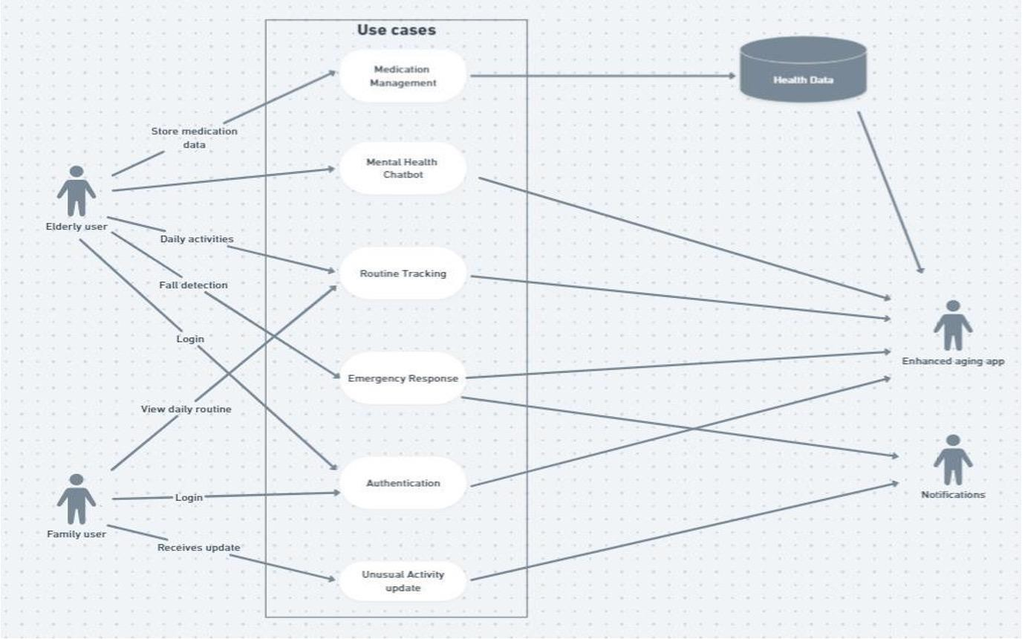

Fig 3.1 Use case diagram

The use case diagram outlines the interactions between users (elderly and family users) and the application, illustrating the various functionalities available to each user type.

#### For Elders:

* + - * **Signup/Login:** Elders can create an account by signing up with their personal details and then log in to the app.
      * **Store medication:** Once logged in, Elders can perform various activities one is store medication with their medicine photos which will be stored in medication management.
      * **monitor Daily Activities:** all the activities such as medication their reports and their daily routines can be checked and reported to their family.
      * **Mental Health Chatbot:** Elders can chat with the chatbot which asses their mental health.
      * **Logout:** Elders can securely logout from their accounts and protect their privacy.

#### For Family:

* + - * **Signup/Login:** Family user can register for an account on the application using their credentials and then log in to access their account.
      * **Logout:** Similar to elderly, family can securely logout from their accounts to end their session.
      * **Monitor activity:** Family have access to Elderly user’s data that allow them to monitor the progress of elders. They can view metrics such as their routine, current location and medications.
      * **Fall Detection/emergency response:** Family get notified with elder’s current location when they fall or anything emergency.

In summary, the use case diagram illustrates how Elders and family interact with the application to engage in various activities such as routine, monitoring activities, and managing health. The platform serves as a comprehensive tool for both elders and family to facilitate effective elderly assistant.

### Activity diagram

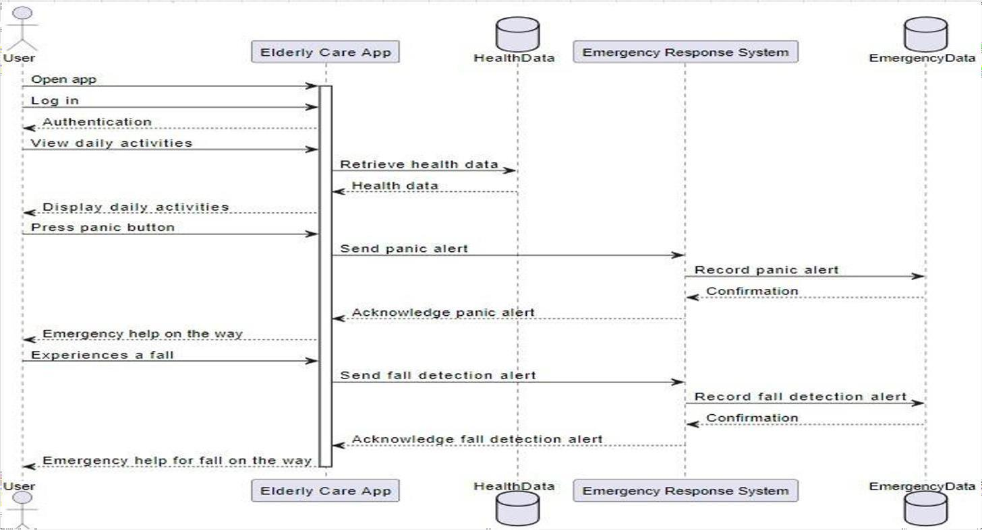

Fig 3.2 Activity diagram

#### Activity Diagram for Elders:

1. **Sign Up/Login:**
   * Start: User selects the "Sign Up" or "Login" option.
   * If the user chooses "Sign Up," they provide personal details and create an account.
   * If the user selects "Login," theyenter their credentials.
   * End: User is logged into the platform.

#### Access the activity:

* + Start: User is logged into the platform.
  + User navigates to the "Dashboard”.
  + User browses various activates and selects desired ones.
  + End: User performs activities

#### Sign Up/Login:

* + Start: User selects the "Sign Up" or "Login" option.
  + If the user chooses "Sign Up," they provide personal details and create an account.
  + If the user selects "Login," theyenter their credentials.
  + End: User is logged into the platform.

#### Access the activity:

* + Start: User is logged into the platform.
  + User navigates to the "Dashboard”.
  + User browses various activates and selects desired ones.
  + End: User performs activities

#### Emergency Response System:

* + Start: User is in emergency.
  + User clicks the emergency button or if any fall detected automatically goes to emergency response.
  + User information is shared to the family interface.
  + End: User has sent the live location.

#### Emergency Data:

* + Start: User medicine routine is stored.
  + User puts the data in their interface.
  + User selects save option.
  + End: User data stored.

#### Monitor Activity:

* + Start: User is logged into the app.
  + User accesses the "Dashboard" section.
  + User views metrics such as routine analysis, medication, reports.
  + End: User has monitored their health progress.

#### Logout:

* + Start: User is logged into the platform.
  + User selects the "Logout" option.
  + End: User is logged out of the platform.

#### Activity Diagram for family:

1. **Sign Up/Login:**
   * Start: User selects the "Sign Up" or "Login" option.
   * If the user chooses "Sign Up," they provide personal details and create an account.
   * If the user selects "Login," theyenter their credentials.
   * End: User is logged into the platform.

#### Monitor Activity:

* + Start: User is logged into the platform.
  + User accesses the "Dashboard" section.
  + User views metrics such as elder’s routines, medication, mental health.
  + End: User has monitored elder’s activities.

#### Add/Remove medications:

* + Start: User is logged into the app.
  + User navigates to the "routine" section.
  + User selects the option to add or remove health data.
  + End: User has added/removed courses and managed course content.

#### Logout:

* + Start: User is logged into the platform.
  + User selects the "Logout" option.
  + End: User is logged out of the platform.

These activity diagrams illustrate the sequential flow of actions performed by elders and family within the R.E.A.C.H app, depicting how they interact with the system to accomplish various tasks.

## Software Requirements Specification

### Functional Requirements

#### Functional Requirements:

* User Authentication and Authorization
* Appointment Booking
* Health Tracking and Medication Management
* Emergency Response System

#### User Authentication and Authorization:

* + The system should facilitate secure account creation for users, ensuring the protection of sensitive information. It should also implement role-based access control, allowing different levels of access such as elderly users, family members, and healthcare professionals, with tailored permissions to perform relevant actions within the system. This ensures that each user group can access and manage the system's features based on their respective roles and responsibilities, contributing to a secure and efficient user experience.

#### Appointment Booking:

* + Appointment booking enables individuals to book appointment with the doctor within the application. The interface should include intuitive navigation and clear instructions to assist users in scheduling appointments and managing activities easily. Integration with calendar systems like Google Calendar or Outlook, along with customizable reminders, can help users stay organized and informed about upcoming events and appointments, enhancing the overall user experience and efficiency of the scheduling process.

#### Health Tracking and Medication Management:

* + A system for tracking health parameters such as vital signs should include intuitive interfaces for inputting and visualizing data, ensuring ease of use for users. Integrating medication schedules with reminders for medication intake can enhance medication adherence and overall health management. Additionally, the system should provide alerts for abnormal readings or missed medication doses, facilitating timely intervention and improving health outcomes for users.

#### Appointment Booking:

* + An emergency button or feature for quick response should be prominently displayed in the app, easily accessible to users in urgent situations. Integration with local emergency services ensures rapid response and appropriate assistance during emergencies. Family notifications should be immediate and informative, alerting designated contacts about the emergency and providing relevant details to coordinate support effectively.

### Nonfunctional Requirements

1. **Accuracy and Performance:** All backend data processing and calculations must achieve an accuracy rate of90%, ensuring precision in health-related information and user data handling. should exhibit optimal performance, with response times for key functionalities not exceeding 500 milliseconds.
2. **Usability:** Intuitive and user-friendly interface for elderly users. - Accessibility features for users with diverse needs.
3. **Scalability:** Ability to scale the application as the user base grows. - Support for new features and functionalities.

### Domain Requirements

Domain requirements for an Elderly app leveraging Elderly assistance and privacy- preserving mechanisms should encompass various aspects to ensure its effectiveness, security, and usability. Here are key domain requirements to consider:

1. **User Authentication and Authorization:**
   * Implement secure user authentication methods, such as username/password, multi- factor authentication, or OAuth, to verify user identities.
   * Define roles and permissions to control access to different functionalities and data based on user roles (e.g., Elder, Family).
2. **Privacy-Preserving Mechanisms:**
   * Utilize homomorphic encryption, differential privacy, or other privacy-preserving techniques to protect sensitive user data, inference, and data aggregation processes.
   * Ensure compliance with data protection regulations (e.g., GDPR, CCPA) by anonymizing or pseudonymizing personal information and obtaining user consent for data processing.
3. **Edge Device Management:**
   * Manage edge computing resources efficiently by deploying machine learning models, workload scheduling algorithms, and resource allocation strategies tailored to edge device capabilities and network conditions.
   * Monitor and optimize edge device performance, connectivity, and energy consumption to ensure reliable and responsive operation in distributed learning environments.
4. **Routine Tracking and Reporting:**
   * Track and visualize Routine, medication, and engagement metrics through interactive dashboards, reports.
   * Enable Family to monitor Elders routine, Live location, health data and look after them timely.
5. **Accessibility and Inclusivity:**
   * In the context of an NLP-based app, ensuring accessibility and inclusivity involves designing the application with features like screen reader compatibility, keyboard navigation, and alternative text. These elements are crucial for accommodating users with disabilities and diverse learning needs, making the app more usable and inclusive for all individuals.

# CHAPTER 4 PROJECT PLANNING

**Chapter – 4**

**PROJECT PLANNING**

## 4.1 Project Planning and Scheduling

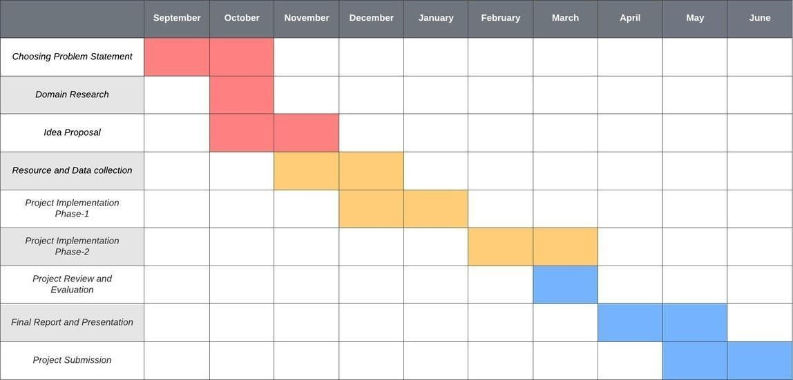

Fig 4.1 Project planning Gantt Chart

The image displayed is a Gantt chart, a popular project management tool used to visualize project schedules and timelines. In this specific Gantt chart, the project timeline spans from September to June, covering a total of ten months. Each month is represented by a separate column, with the project stages distributed across the timeline to indicate when they are expected to occur.

The Gantt chart outlines various stages of the project development process, each represented by a colored bar extending horizontally across the timeline. The stages included in the chart are as follows:

* Choosing Problem Statement: This initial stage involves identifying and defining the main issue or challenge that the project aims to address. It sets the foundation for the rest of the project activities.
* Domain Research: In this stage, research is conducted to explore the relevant domains, industries, or fields related to the project. It involves gathering information and understanding the context in which the project will operate.

Remote Elderly Assistant and Care Hub

* Idea Proposal: During this phase, project ideas and solutions are proposed and evaluated. It involves brainstorming, ideation, and selecting the most viable concepts to move forward with.
* Resource and Data Collection: This stage focuses on gathering the necessary resources, data, and information required for the project. It involves sourcing materials, collecting data, and ensuring that all necessary resources are available.
* Project Implementation: The implementation phase involves putting the project plan into action. Tasks are executed, and project activities are carried out according to the defined schedule and requirements.
* Project Review and Evaluation: This stage involves assessing the progress of the project, identifying any issues or challenges, and evaluating the effectiveness of the project implementation. It allows for adjustments to be made to ensure project success.
* Final Report and Presentation: In this phase, a final report is prepared summarizing the project outcomes, findings, and recommendations. A presentation may also be delivered to stakeholders to communicate the project results.
* Project Submission: The final stage involves submitting the project deliverables, reports, and any other required documentation. It marks the completion of the project and the formal handover of results to stakeholders.

The Gantt chart provides a visual representation of the project timeline, allowing project managers and team members to track progress, manage dependencies, and allocate resources effectively. By displaying the project stages in a chronological order, the chart helps in planning and scheduling activities, identifying potential bottlenecks, and ensuring that the project stays on track.

Overall, the Gantt chart serves as a valuable tool for project management, facilitating communication, coordination, and decision-making throughout the project lifecycle. It enables stakeholders to have a clear understanding of the project timeline, milestones, and deliverables, ultimately contributing to the successful completion of the project within the specified timeframe and budget.

# CHAPTER 5 SYSTEM DESIGN

**Chapter 5**

Remote Elderly Assistance and Care Hub

**SYSTEM DESIGN**

## System Architecture

System architecture refers to the overall design and organization of a computer system, which includes hardware components, software components, and the communication and interaction between them. It defines the way in which the system's components are connected, how they operate together to achieve the system's objectives, and how they are managed and maintained over time. A well-designed system architecture is critical for ensuring that a computer system is scalable, secure, reliable, and maintainable.

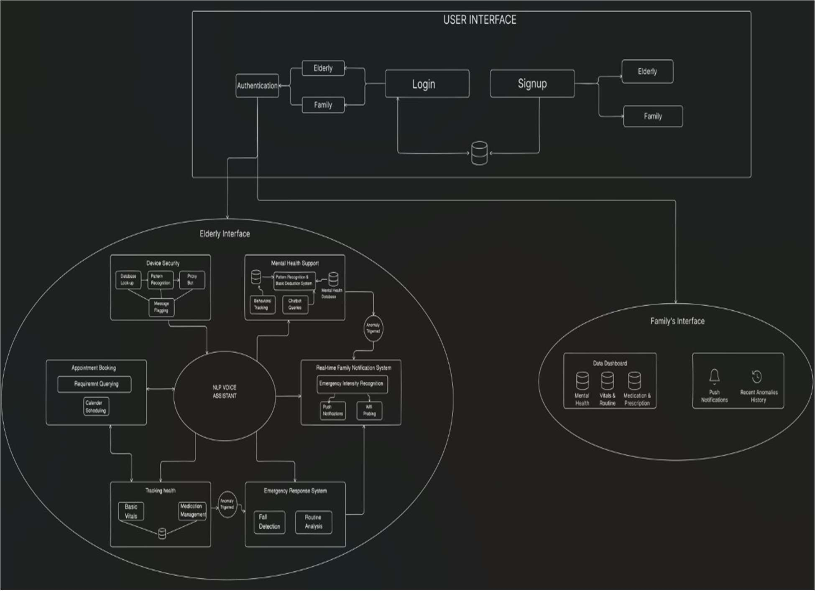

Fig 5.1 System Architecture

The architecture is strategically divided into three main sections – General User Interface, Elderly Interface, and Family Interface – with a focus on addressing the unique needs of

both elderly individuals and their family members. The General User Interface serves as the central hub for all users, providing robust authentication mechanisms for secure access

to the platform. Upon authentication, users are seamlessly categorized into two distinct groups: Elderly and Family.

The Elderly Interface is meticulously designed to cater to the specific needs and preferences of elderly users, offering a suite of tailored features aimed at enhancing their overall well-being and independence. The Space Reality View immerses them in an intuitive and engaging virtual environment, fostering cognitive stimulation and interactive experiences. The World Health Report empowers elderly users with valuable insights into global health trends and relevant information, enabling them to stay informed about their health status and make informed decisions. The Real-Time Health Monitor System with an Emergency Response System ensures continuous monitoring of vital signs and immediate assistance in case of emergencies, providing peace of mind and security. Additionally, the Appointment Booking feature simplifies the process of scheduling essential services such as doctor visits and cleaning, streamlining daily management tasks for elderly users.

Conversely, the Family Interface is specifically tailored to meet the needs of family members, providing comprehensive tools for monitoring and managing the health and well- being of their elderly loved ones. Data Statements offer detailed reports and analytics on various health metrics, allowing family members to track progress and identify any potential concerns. Notifications keep family members informed about important events and updates related to the well-being of their elderly relatives, facilitating proactive intervention when necessary. Real-Time Monitoring provides a live feed of vital health information and activity updates, enabling family members to stay connected and responsive to the needs of their elderly loved ones.

Overall, this architecture embodies a holistic approach to remote elderly care, leveraging technology to bridge the gap between elderly individuals and their families. By combining intuitive interfaces with advanced features, our application aims to facilitate seamless communication, monitoring, and management of health-related services, ultimately enhancing the quality of life for elderly users and providing peace of mind for their families.

## Module Decomposition

#### NLP Voice Assistant:

The NLP (Natural Language Processing) Voice Assistant serves as the primary interface for elderly users to interact with the application. It facilitates hands-free navigation and control, enabling users to perform various tasks and access information using voice commands. The voice assistant integrates advanced NLP algorithms to understand and interpret natural language input from users. It supports a wide range of commands related to scheduling appointments, managing medication, checking health metrics, and accessing entertainment features like the Space Reality View. This module provides a user-friendly and accessible interface for elderly users, especially those with limited mobility or dexterity, enhancing the overall user experience by streamlining navigation and reducing reliance on manual input methods.

#### Fraudulent SMS Detection:

This module is designed to safeguard elderly users from potential scams and fraudulent activities conducted via SMS messages. It analyzes incoming messages in real-time to identify suspicious content and alert users about potential threats. Leveraging machine learning algorithms, the system examines message content, sender information, and other metadata to detect patterns indicative of fraudulent behavior. It can recognize common scam tactics such as phishing attempts, lottery scams, and fake prize notifications. The benefits include protecting elderly users from falling victim to scams and financial fraud, thereby preserving their financial security and peace of mind. It helps instill trust and confidence in using mobile communication channels for staying connected with friends, family, and caregivers.

#### Mental Health Chatbot:

The Mental Health Chatbot offers emotional support and basic mental health assistance to elderly users through conversational AI. It serves as a virtual companion capable of

engaging in empathetic conversations and providing guidance on coping strategies and self-care practices. Powered by sophisticated natural language processing models, the chatbot can engage users in meaningful dialogues, assess their emotional state, and offer appropriate responses and interventions. It may provide relaxation techniques, mindfulness exercises, or referrals to professional mental health services if needed. The benefits include addressing the mental and emotional well-being of elderly users by providing them with a supportive and non-judgmental outlet for expressing their feelings and concerns. It helps alleviate feelings of loneliness, anxiety, and depression commonly experienced by elderly individuals living alone or in isolation.

#### Fall Detection

The Fall Detection module utilizes sensors and algorithms to detect falls and alert caregivers or emergency services promptly. It continuously monitors the user's movements and analyzes sensor data to identify sudden changes indicative of a fall. Upon detecting a fall, the system triggers an alert notification, which can be sent to designated caregivers or emergency contacts. This module provides elderly users with added safety and peace of mind, ensuring prompt assistance in case of accidents or medical emergencies. It enhances their independence and allows them to live with confidence knowing that help is readily available when needed.

#### Medication, Prescription, and Reports Management:

This module helps elderly users manage their medication schedules, prescriptions, and medical reports for easy access and monitoring. It provides a user-friendly interface for organizing and tracking medications, including dosage instructions, refill reminders, and medication histories. Additionally, users can upload and store medical reports and prescriptions securely within the app, ensuring they have quick access to important health information whenever needed. The benefits include promoting medication adherence, reducing the risk of medication errors, and facilitating better communication with

healthcare providers. This module empowers elderly users to take control of their medication regimen and maintain their overall health more effectively.

#### Tracking Vitals:

The Tracking Vitals module monitors vital signs like heart rate and blood pressure to track the health status of users in real-time. It utilizes wearable sensors or smart devices to collect and analyze vital sign data continuously. The system provides visualizations and alerts for abnormal readings, allowing users and caregivers to monitor changes in health status and take appropriate action if necessary. This module enhances proactive healthcare management by enabling early detection of potential health issues and facilitating timely interventions. It promotes a proactive approach to health monitoring, empowering elderly users to maintain their well-being and quality of life.

#### Family Interface with Notification System:

The Family Interface with Notification System allows family members to stay informed about the elderly’s condition and any alerts generated by the system. It provides a centralized dashboard where family members can view real-time updates on the health status and activity of their elderly relatives. The notification system sends alerts for events such as falls, missed medication doses, or abnormal vital sign readings, ensuring that family members can respond promptly to any emergencies or concerns. This module fosters communication and collaboration among family members, facilitating a coordinated approach to elderly care and support.

#### Routine Analysis:

The Routine Analysis module analyzes daily activity patterns to offer insights and suggestions for healthy habits. It tracks various aspects of the user's routine, including sleep patterns, physical activity levels, and dietary habits, using data from sensors or wearable devices. The system uses machine learning algorithms to identify trends and patterns in the user's behavior.

## Algorithm Design

#### Algorithm: Fraudulent SMS Detection

* + 1. Start: Initialize the system to begin SMS analysis.
    2. Detect Fraudulent Activity: Analyze incoming SMS for potentially fraudulent activity.
    3. Keyword Matching:

If the message contains predefined fraudulent keywords, proceed to step 4. If not, go to step 5.

* + 1. Message Contains Keyword: Mark the message as fraudulent. End the algorithm.
    2. Unusual Pattern Detection:

Check for unusual patterns in the message.

If no unusual patterns are found, mark the message as safe and end the algorithm. If unusual patterns are detected, proceed to step 6.

* + 1. Sender Verification:

Verify if the sender is in the user’s contact list.

If the sender is not in contacts and the message contains unexpected characters, mark the message as fraudulent.

Otherwise, mark the message as safe.

This algorithm utilizes a combination of keyword matching, pattern recognition, and sender verification to determine the legitimacy of an SMS message. It ensures that messages are thoroughly checked for common signs of fraud before being classified.

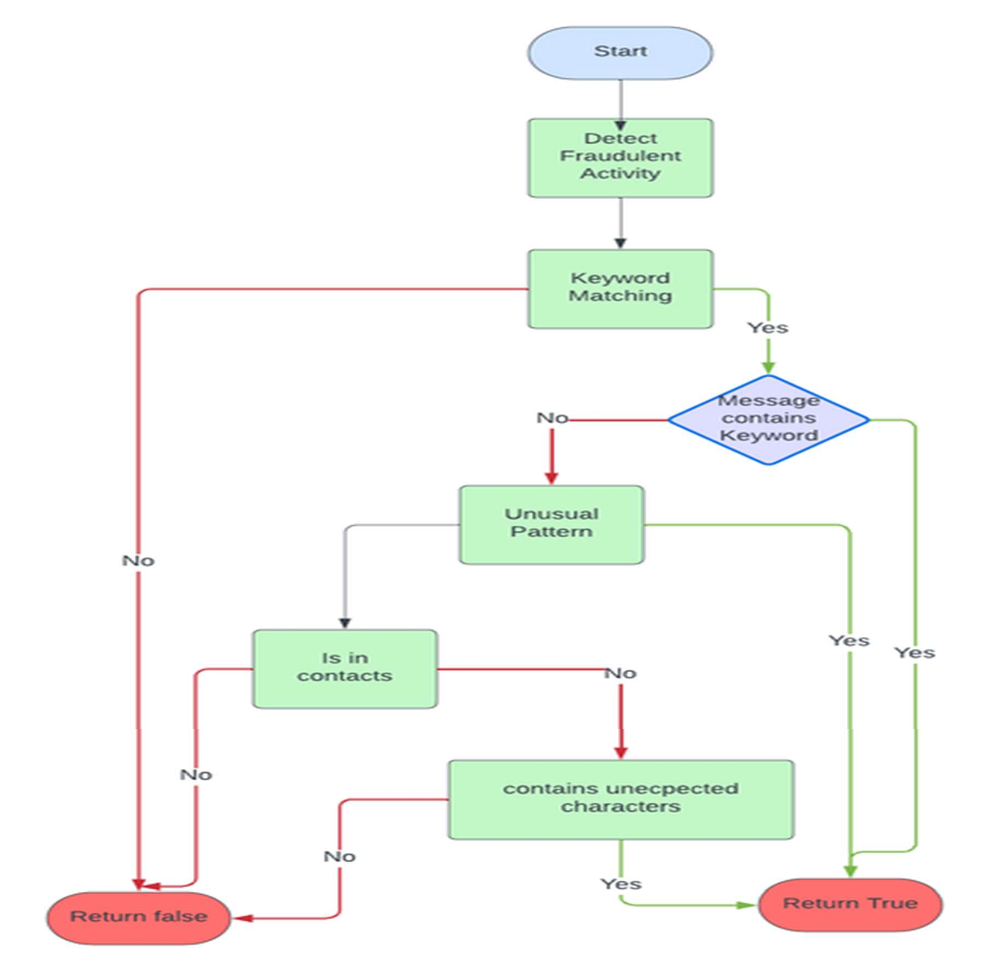

Fig 5.4 Flow Chart

Remote Elderly Assistance and Care Hub

Department of AI&ML, BIT 2023-24 36

# CHAPTER 6 IMPLEMENTATION

**Chapter - 6**

Remote Elderly Assistance and Care Hub

**IMPLEMENTATION**

## Implementation Approaches

### Firebase for Infrastructure Management

Firebase is a comprehensive platform provided by Google that offers a wide range of services for mobile and web application development. It includes features such as authentication, real-time database, cloud storage, and cloud messaging, among others. In your application, Firebase plays a crucial role in enabling secure authentication mechanisms, efficient data management, and seamless communication between users and the application's backend services.

First and foremost, Firebase's authentication service provides a robust framework for user authentication, allowing users to securely log in or sign up to access the application's features. With Firebase Authentication, you can implement various authentication methods, including email/password authentication, social login (such as Google or Facebook), and phone number authentication, ensuring flexibility and convenience for users.

Additionally, Firebase Realtime Database serves as a centralized repository for storing and synchronizing real-time data across devices. This is particularly valuable for your application, as it allows you to store crucial user data such as vital signs, medication schedules, prescriptions, and medical reports in a structured and easily accessible manner. The real-time synchronization feature ensures that any updates made to the database are immediately reflected across all connected devices, providing users with up-to-date information and ensuring consistency across the application.

Moreover, Firebase Cloud Storage offers scalable and secure cloud storage solutions for storing and serving user-generated content, such as images, documents, and multimedia files. By utilizing Firebase Cloud Storage, you can efficiently store and manage images of medication, prescriptions, and reports, as well as any other multimedia assets associated with user data. This helps optimize storage resources, improve performance, and ensure reliable access to user-generated content.

In summary, Firebase provides a comprehensive suite of services that are instrumental in powering the core functionalities of your application. From secure authentication and real-time data synchronization to scalable cloud storage solutions, Firebase offers the tools and infrastructure needed to build a robust and user-friendly application for remote elderly care. Its seamless integration with your application architecture streamlines development efforts and enhances the overall user experience, making Firebase an indispensable component of your application's backend infrastructure.

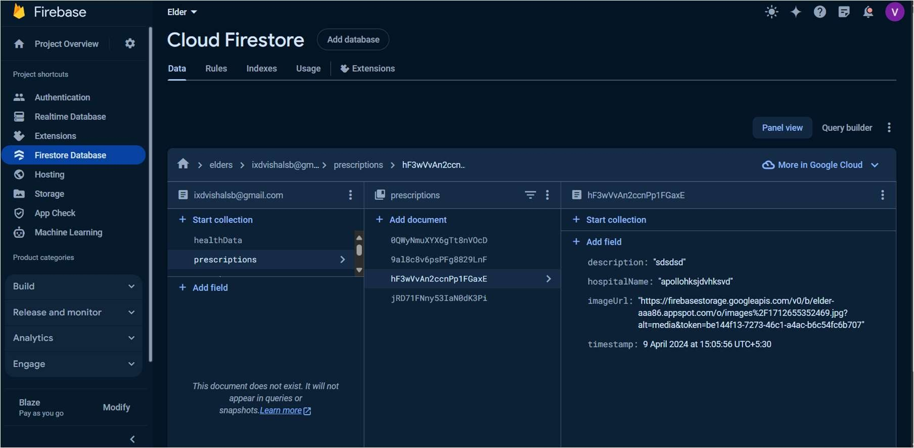

Fig 6.1.1 Firebase Dashboard

### OpenStreetMap for Routine Analysis

OpenStreetMap (OSM) is an open-source mapping platform that provides detailed and up-to-date geographic data for locations worldwide. It offers a vast repository of map data, including streets, landmarks, points of interest, and geographical features, contributed and maintained by a global community of volunteers. In your application, OpenStreetMap serves as a valuable tool for geolocation services and spatial analysis, particularly for implementing the routine analysis feature that triggers alerts when a user moves beyond a predefined boundary.

One of the key advantages of OpenStreetMap is its extensive coverage and level of detail, which surpasses many commercial mapping services. The data available on OSM is constantly updated and refined by a diverse community of contributors, ensuring that users have access to accurate and reliable geographic information. This high level of detail and accuracy makes OpenStreetMap well-suited for applications that require precise location data, such as your routine analysis feature.

Moreover, OpenStreetMap offers flexibility and customization options that allow developers to tailor map data to their specific needs. This includes the ability to define custom boundaries, overlay additional layers of data, and perform spatial analysis to extract insights from geographic data. In your application, OpenStreetMap enables you to define a circular boundary around a user's home location and monitor their movements in real-time. By leveraging OSM's APIs and libraries, you can efficiently track the user's location and trigger alerts when they move beyond the predefined boundary, providing peace of mind for family members and caregivers.

Additionally, OpenStreetMap's open-source nature and community-driven model make it a cost-effective and accessible solution for developers. Unlike proprietary mapping platforms that may come with licensing fees or usage restrictions, OpenStreetMap provides free access to its map data and APIs, allowing developers to integrate mapping functionality into their applications without incurring additional costs. This

democratization of mapping technology ensures that developers of all sizes and budgets can leverage the power of geolocation services to enhance their applications.

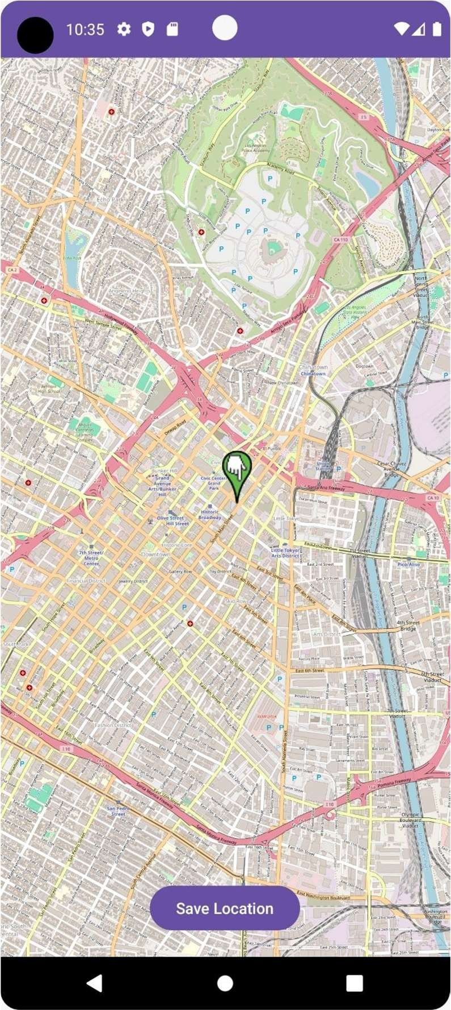In summary, OpenStreetMap offers a robust and flexible mapping platform that is well-suited for implementing geolocation services and spatial analysis in your application. Its extensive coverage, accuracy, and customization options make it a valuable tool for monitoring user movements, triggering alerts, and enhancing the overall functionality and user experience of your remote elderly care application.

Fig 6.2.1 OpenStreetMap Snapshot

Department of AI&ML, BIT 2023-24 40

# CHAPTER 7 TESTING

**Chapter - 7**

**TESTING**

### Testing Approach

Testing is a systematic and disciplined process of evaluating a software application or system to identify defects, errors, or discrepancies between expected and actual behaviour. It involves executing the software with the intention of finding bugs, verifying that it meets specified requirements, and ensuring its overall quality.

The primary goal of testing is to uncover issues in the software and provide feedback to the development team, allowing them to address and fix any identified problems. Testing helps to ensure that the software functions as intended, is reliable, and meets the needs and expectations of its users.

### Unit Testing

Unit testing, a testing technique using which individual modules are tested to determine if there are any issues by the developer himself. It is concerned with functional correctness of the standalone modules. Unit Testing is done during the development (coding phase) of an application by the developers. The goal of unit testing is to isolate each part of the program and show that the individual parts are correct. Unit testing finds problems early in the development cycle. This includes both bugs in the programmer's implementation and flaws or missing parts of the specification for the unit

#### UTC-1: Fall Detection Model

Unit testing for a fall detection model within an Android app involves breaking down the code into individual units, typically methods or functions, and testing each unit in isolation to ensure that it behaves as expected. For a fall detection feature, this entails testing various aspects of the model's functionality, such as its ability to accurately detect a fall event, trigger notifications to emergency contacts, and handle different scenarios gracefully. The unit tests for the fall detection model would focus on verifying its core functionality,

including the algorithm's accuracy in identifying falls based on sensor data collected by the device. By thoroughly testing each unit of the fall detection model, developers can gain confidence in its reliability and robustness, helping to ensure that it performs effectively in real-world situations. In the unit testing framework for the fall detection model, an important test case to include is the handling of multiple fall detections within a short time frame. Specifically, the model should be designed to treat any subsequent falls detected within 15 minutes of the first as false positives. This parameter is essential to avoid over- alerting emergency contacts or triggering unnecessary response actions, thereby reducing the risk of undue stress and resource deployment.

|  |  |  |  |  |
| --- | --- | --- | --- | --- |
| **Test Case** | **Input Data** | **Expected Output** | **Actual Output** | **Pass/Fail** |
| Test 1 | Basic Fall Detection | Fall is detected and family is notified. | Fall is detected and family is notified. | Pass |
| Test 2 | False Positive Test Case | A subsequent fall in under 15 minutes is considered false  positive. | A subsequent fall in under 15 minutes is considered false  positive. | Pass |
| Test 3 | One to Many Emergency Contacts | All the emergency contacts are notified. | All the emergency contacts are notified. | Pass |
| Test 4 | Network Connectivity Issue | Message is sent to a nearby bystander through Wi-Fi. | No message is sent. | Fail |

Table 7.1 Unit Testing – 1

In this table:

* “Input Data” represents the input features (e.g., time spent, quiz scores, quiz

attempts).

* + - * “Expected Output” represents the expected class label predicted by the model.
* “Pass/Fail” indicates whether the predicted output matches the expected output.

#### UTC-1: User Interface Testing

The user interface (UI) module is a critical component of our system, providing users with an intuitive and engaging platform.

Ensuring the UI functions as intended is essential for delivering a seamless user experience.

|  |  |  |  |  |
| --- | --- | --- | --- | --- |
| **Test Case** | **Input Data** | **Expected Output** | **Actual Output** | **Pass/Fail** |
| Test 1 | User submits a medicine’s data. | Reminder is set up, image and other data is backed up to cloud. | Reminder is set up, image and other data is backed up to cloud. | Pass |
| Test 2 | User logs in with valid credentials | User is directed to the home page | User is directed to the home page | Pass |
| Test 3 | User attempts to log in with invalid credentials | Error message: “Invalid username or password” | Error message: “Invalid username or password” | Pass |
| Test 4 | User sends a query to the chatbot | The chatbot responds based on the query and if a particular threshold is met, then notifies the family. | The chatbot responds based on the query and if a particular threshold is met, then notifies the family. | Pass |
| Test 5 | User roams out of the designated area. | Routine Analysis notifies the family and sends location update  every minute. | Routine Analysis notifies the family and sends location update  every minute. | Pass |
| Test 6 | Family member accesses the elder’s records. | All the medical records and data is displayed. | All the medical records and data is displayed. | Pass |

Table 7.2 Unit Testing - 2

In these test cases:

* + "Input/Action" describes the user action or input being tested.
* "Expected Output" indicates the expected behaviour or result of the action.
* "Actual Output" shows what the system actually does in response to the input. •

"Pass/Fail" determines whether the actual output matches the expected output.